Order Of Service

Singing: Psalm 65—CW page 89

Reading: Psalm 47

Opening Hymn: CW 232

Reading: Galatians 2:11-21

Request Hymn: CW Supplement 735

Reading: Mark 9:1-8

Sermon Hymn: CW 363

Sermon Text: Luke 18:18-23

Lacking One Thing

Prayer

The Apostles’ Creed, TLH page 12

Holy Communion

The Lord's Prayer

The Blessing

Closing Hymn: CW 396

************

Koinonia Hour

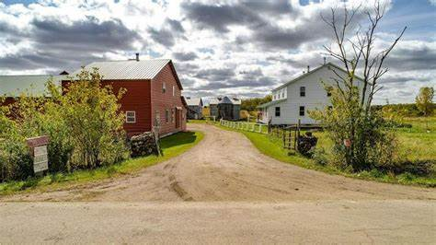

Amish Farm In Wisconsin

Water
Of
Life
4 December 2022

W A T E R O F L I F E

Independent Christian Church—Conservative Lutheran Doctrine

Worship Service: 9:30 a.m.

Larry Cooper, Pastor E-Mail address:
111 N. Ridge Road lcooper@wateroflife.cc
Coon Valley, WI 54623 Web Site:
www.wateroflife.cc

* * * * * * * * * * * * * * * * * * * * * * * * * * *

Sermon Text: Luke 18:18-23

Lacking One Thing

* * * * * * * * * * * * * * * * * * * * * * * * * * *

18 And a certain ruler asked him, saying, Good Master, what shall I do to inherit eternal life?
19 And Jesus said unto him, Why callest thou me good? none is good, save one, that is, God.
20 Thou knowest the commandments, Do not commit adultery, Do not kill, Do not steal, Do not bear false witness, Honour thy father and thy mother.
21 And he said, All these have I kept from my youth up.
22 Now when Jesus heard these things, he said unto him, Yet lackest thou one thing: sell all that thou hast, and distribute unto the poor, and thou shalt have treasure in heaven: and come, follow me.
23 And when he heard this, he was very sorrowful: for he was very rich.

